**Unirac ULA Specs Request**

Site: <http://unirac.com/equestionnaire.php>

Unirac designs their custom solutions to accommodate site conditions and applicable codes. If you need help configuring your system, please fill out our eQuestionnaire to help us understand your PV mounting needs. In return, you'll receive a bill of materials and pricing for your selected product solution. Please allow up to 5 business days to receive a quote.

Please confirm the accuracy of your inputs. Subsequent revisions may incur a fee. Fields with an asterisk (*) are required.

# Customer Information

Company *:

Trinity Solar

First Name *:

Kevin

Last Name *:

Kura

Phone *:

732-616-1928

Email *: Requestors Email

Project Name *:

Customers Last, First name

Address:

2211 Allenwood Road

City:

Wall

State/Province:

New Jersey

Zip:

07719

Distributor Name :

Warshauer Electric

Distributor Contact Name :

Gene Fay

Distributor Contact Phone:

Distributor Contact E-Mail :

# Site Information

Project Zip Code *:

(Customers Zip Code)

Installation Type *:



Ground Mount

Product Family *:



U-LA

Building Code *:



ASCE 7-10

Basic Wind Speed (mph)*:



110

Wind Exposure Category *: Ground Snow Load (psf)*:



B



Please Select

(As Per Documents)

Seismic Zone*: As per Documents

Seismic Ss: As per Documents



Seismic S1: As per Documents



# Array Information

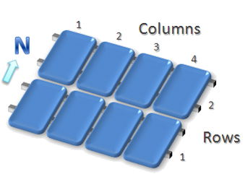

Module Manufacturer *: Module Model *:



--None--

Total Number of Modules *:

Number of Rows *:

Number of Columns *:



Number of Arrays *:



Module Tilt Angle*:

30

We only provide engineering for an overall PV-module tilt (roof tilt + racking tilt) up to 45 degrees above horizontal.

**In order to receive a custom quotation for your specific array, please fill out the required information below. Please note that all of the information is required in order to receive an accurate quotation. A quotation is a detailed bill of materials along with engineering analysis based on all inputs.**

# Specific Array Information

Module Orientation*:



Landscape

Preferred Mounting Method*: <65spf = Bottom Clips >65spf = Top Clips



--None--

Front Edge Height (ft)*:



2

# Comments

Project Comments or Details:

Engineer Email State Email Project Address



Submit Request for Quotation